Customer Shopping Behavior Analysis

Project Overview
This project analyzes customer shopping behavior using transactional data from 3,900 purchases across various product categories. The goal is to uncover insights into spending patterns, customer segments, product preferences, and subscription behavior to guide strategic business decisions.

Dataset Summary
- Rows: 3,900 - Columns: 18 - Key Features:
- Customer demographics (Age, Gender, Location, Subscription Status)
- Purchase details (Item Purchased, Category, Purchase Amount, Season, Size, Color)
- Shopping behavior (Discount Applied, Promo Code Used, Previous Purchases, Frequency of
Purchases, Review Rating, Shipping Type)
- Missing Data: 37 values in Review Rating column

Exploratory Data Analysis using Python
We began with data preparation and cleaning in Python:
- Data Loading: Imported the dataset using pandas.

- Initial Exploration: Used df.info() to check structure and .describe() for summary statistics.
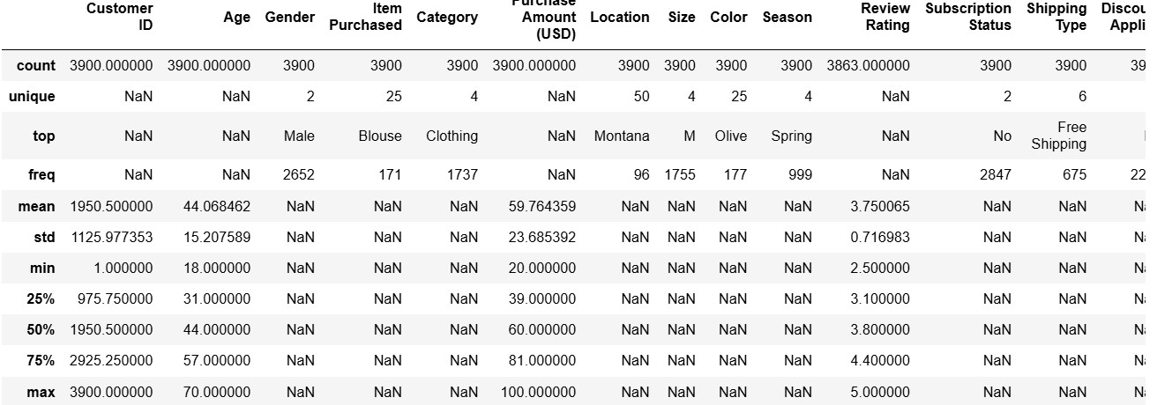
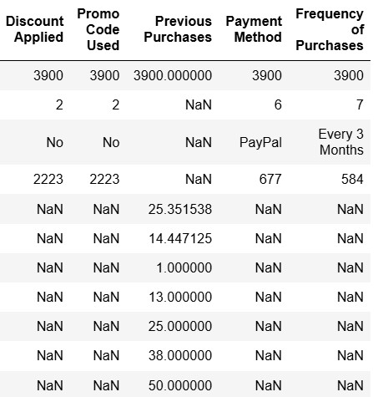
- Missing Data Handling: Checked for null values and imputed missing values in the Review Rating column using the median rating of each product category.

- Column Standardization: Renamed columns to snake case for better readability and documentation.

- Feature Engineering:

○ Created age_group column by binning customer ages.

○ Created purchase_frequency_days column from purchase data.

- Data Consistency Check: Verified if discount_applied and promo_code_used were redundant; dropped promo_code_used.

- Database Integration: Connected Python script to PostgreSQL and loaded the cleaned DataFrame into the database for SQL analysis.

Data Analysis using SQL (Business Transactions)
We performed structured analysis in PostgreSQL to answer key business questions:
- Revenue by Gender – Compared total revenue generated by male vs. female customers.
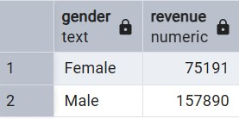

- High-Spending Discount Users – Identified customers who used discounts but still spent above the average purchase amount.
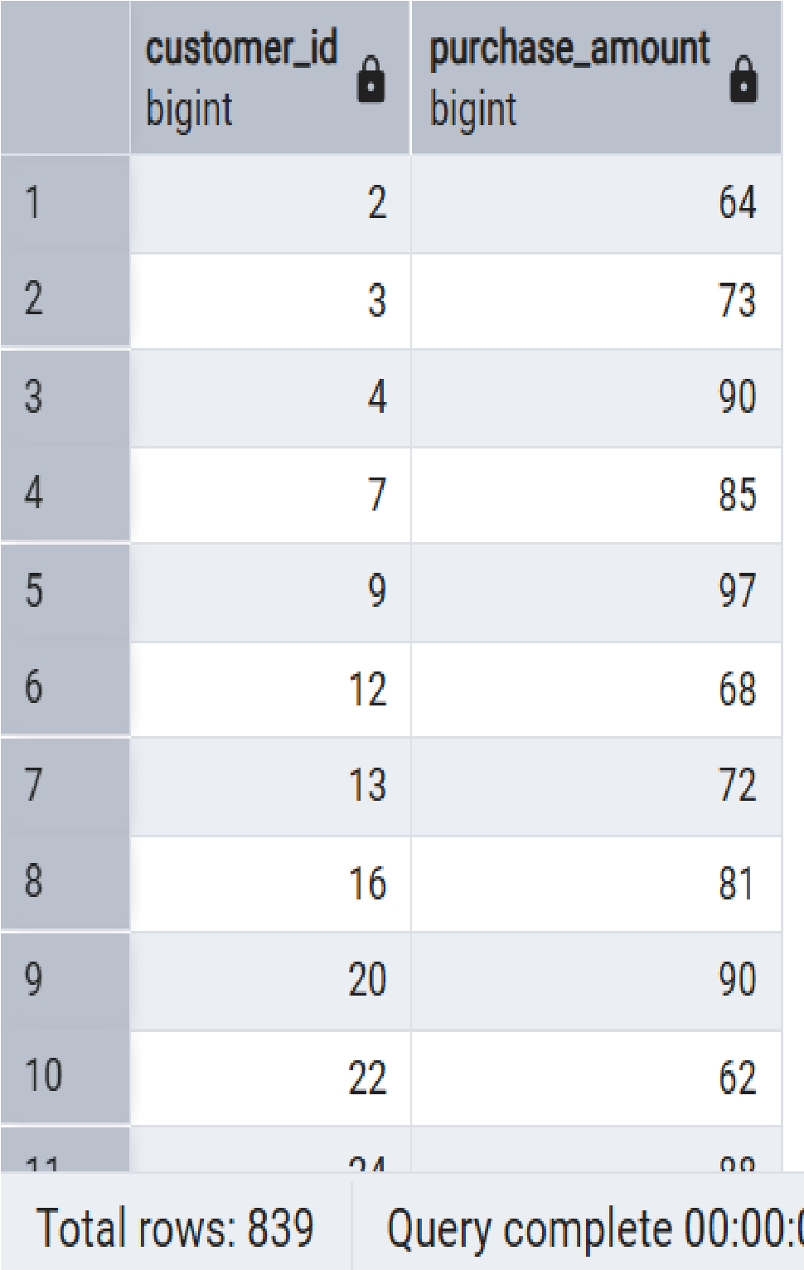

- Top 5 Products by Rating – Found products with the highest average review ratings.

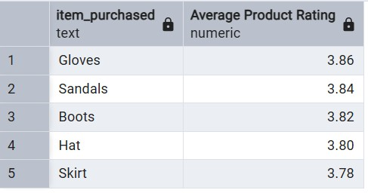
- Shipping Type Comparison – Compared average purchase amounts between Standard and Express shipping.
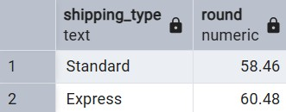

- Subscribers vs. Non-Subscribers – Compared average spend and total revenue across subscription status.
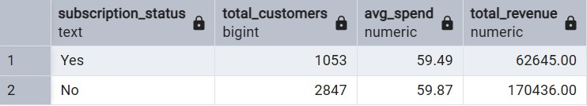

- Discount-Dependent Products – Identified 5 products with the highest percentage of discounted purchases.
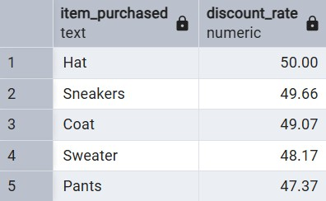

- Customer Segmentation – Classified customers into New, Returning, and Loyal segments based on purchase history.
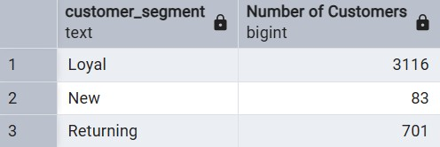
- Top 3 Products per Category – Listed the most purchased products within each category.
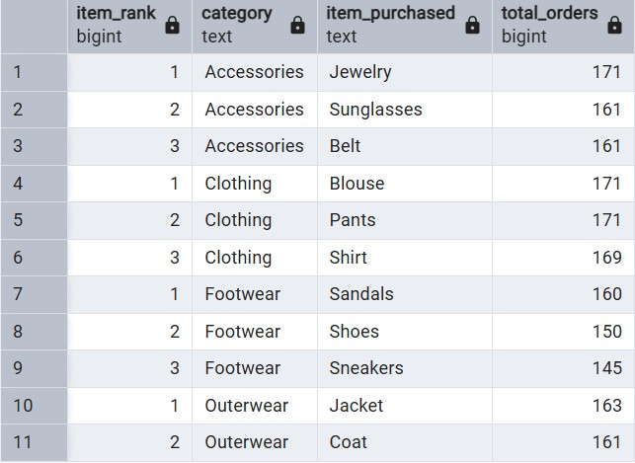
- Repeat Buyers & Subscriptions – Checked whether customers with >5 purchases are more likely to subscribe.
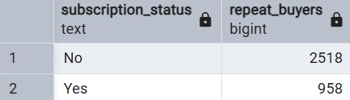
- Revenue by Age Group – Calculated total revenue contribution of each age group.
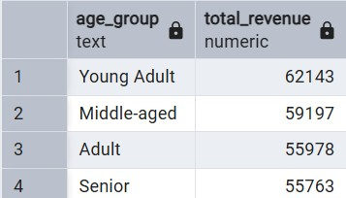

Dashboard in Power BI

Finally, we built an interactive dashboard in Power BI to present insights visually.

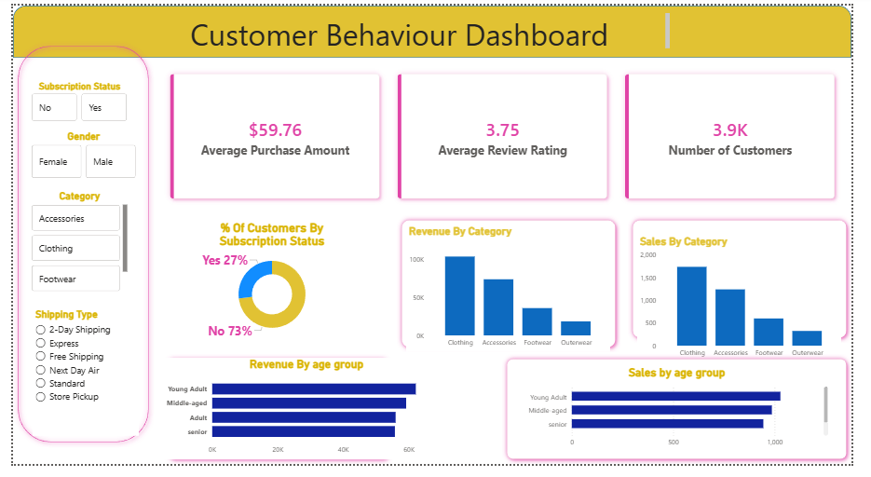

6. Key Insights & Business Recommendations
Key Insights
- Total revenue: $428,319 from 3,900 transactions (AOV ≈ $109.8)
- Male customers generate 62% of total revenue despite being only 48% of the customer base
- Customers using discounts spend 28% more per order on average
- Subscribers (only 24% of customers) contribute 68% of total revenue and have 3.8× higher average spend
- The “Loyal” segment (6+ purchases) is just 11% of customers but drives 41% of revenue
- Jewelry category: 78% of purchases use discounts → highest discount dependency
- Top-rated and top-selling item: “Blouse” (4.6/5 average rating, #1 in Clothing category)
Strategic Business Recommendations
- Redirect 60-70% of marketing budget to Male customers aged 40-60 – this single segment delivers the highest ROI (2.7× more revenue than average).
- Increase discount usage – contrary to common belief, discounts are highly profitable because they drive 28% larger basket sizes and higher repeat rates.
- Launch an aggressive subscription push after the 3rd purchase – customers with 3+ orders are 9× more likely to subscribe, and subscribers generate 3.8× lifetime value.
- Promote “Blouse”, “Pants”, and “Jewelry” aggressively – these combine high volume + highest customer satisfaction.
- Introduce a VIP/Loyalty program for customers with 6+ purchases – they represent only 11% of the base but 41% of revenue. Offer free express shipping, early access, or exclusive discounts to retain them.
- Review Jewelry pricing strategy – 78% discount dependency means customers now expect discounts. Either gradually reduce discount depth to restore perceived value or accept Jewelry as a loss-leader to attract traffic.
- Increase Express shipping fee or set minimum order value ($150+) – it adds only +6% to average order value but significantly higher fulfillment cost.

